Pick3StatsC4.xslm
Track green states only = real mechanic balls
The rest = computer (don’t trust)

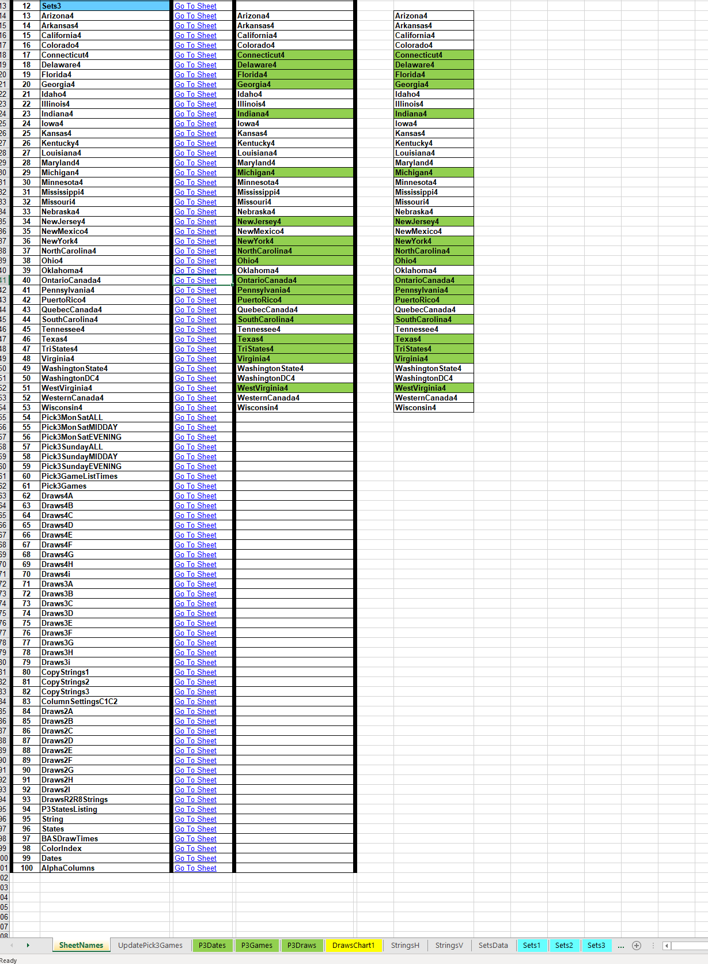

State sheets with string tables
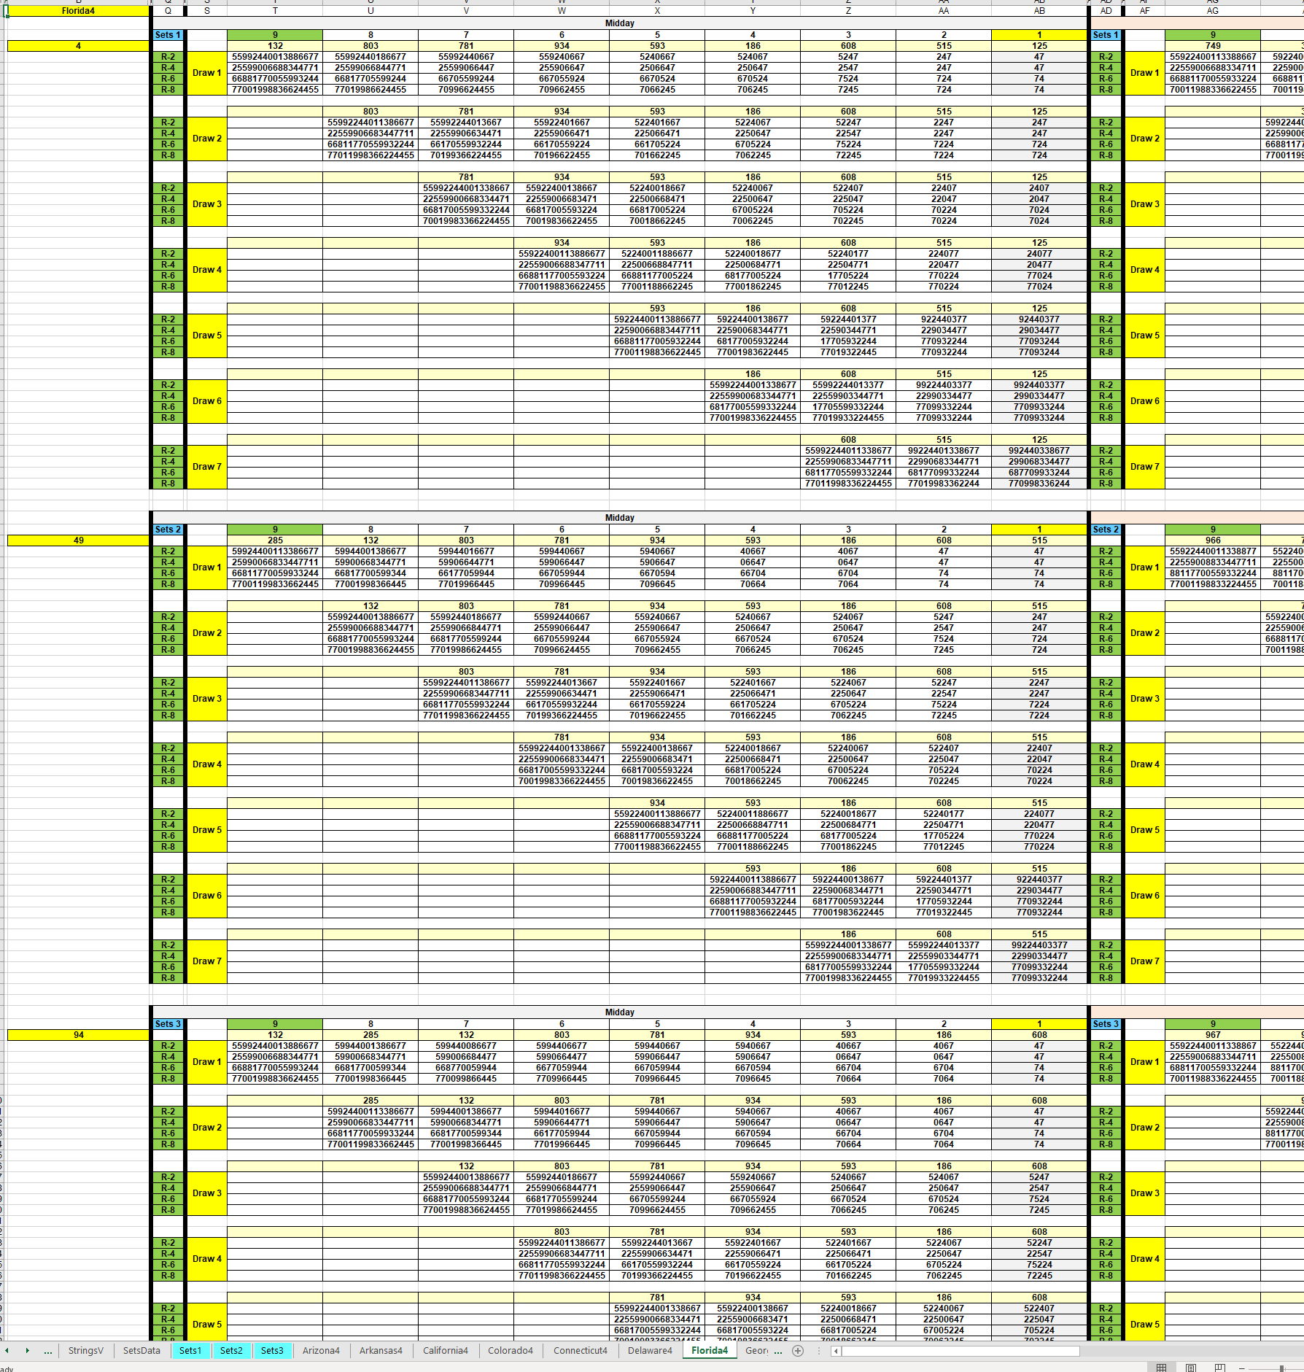

___________________________________________________________________________________________________________________________________________________
Streamlit App

Programmed Datasets:
- Midday/Evening/Combined
- Symbols * and ** (hot zones)
- Color Dataset significance

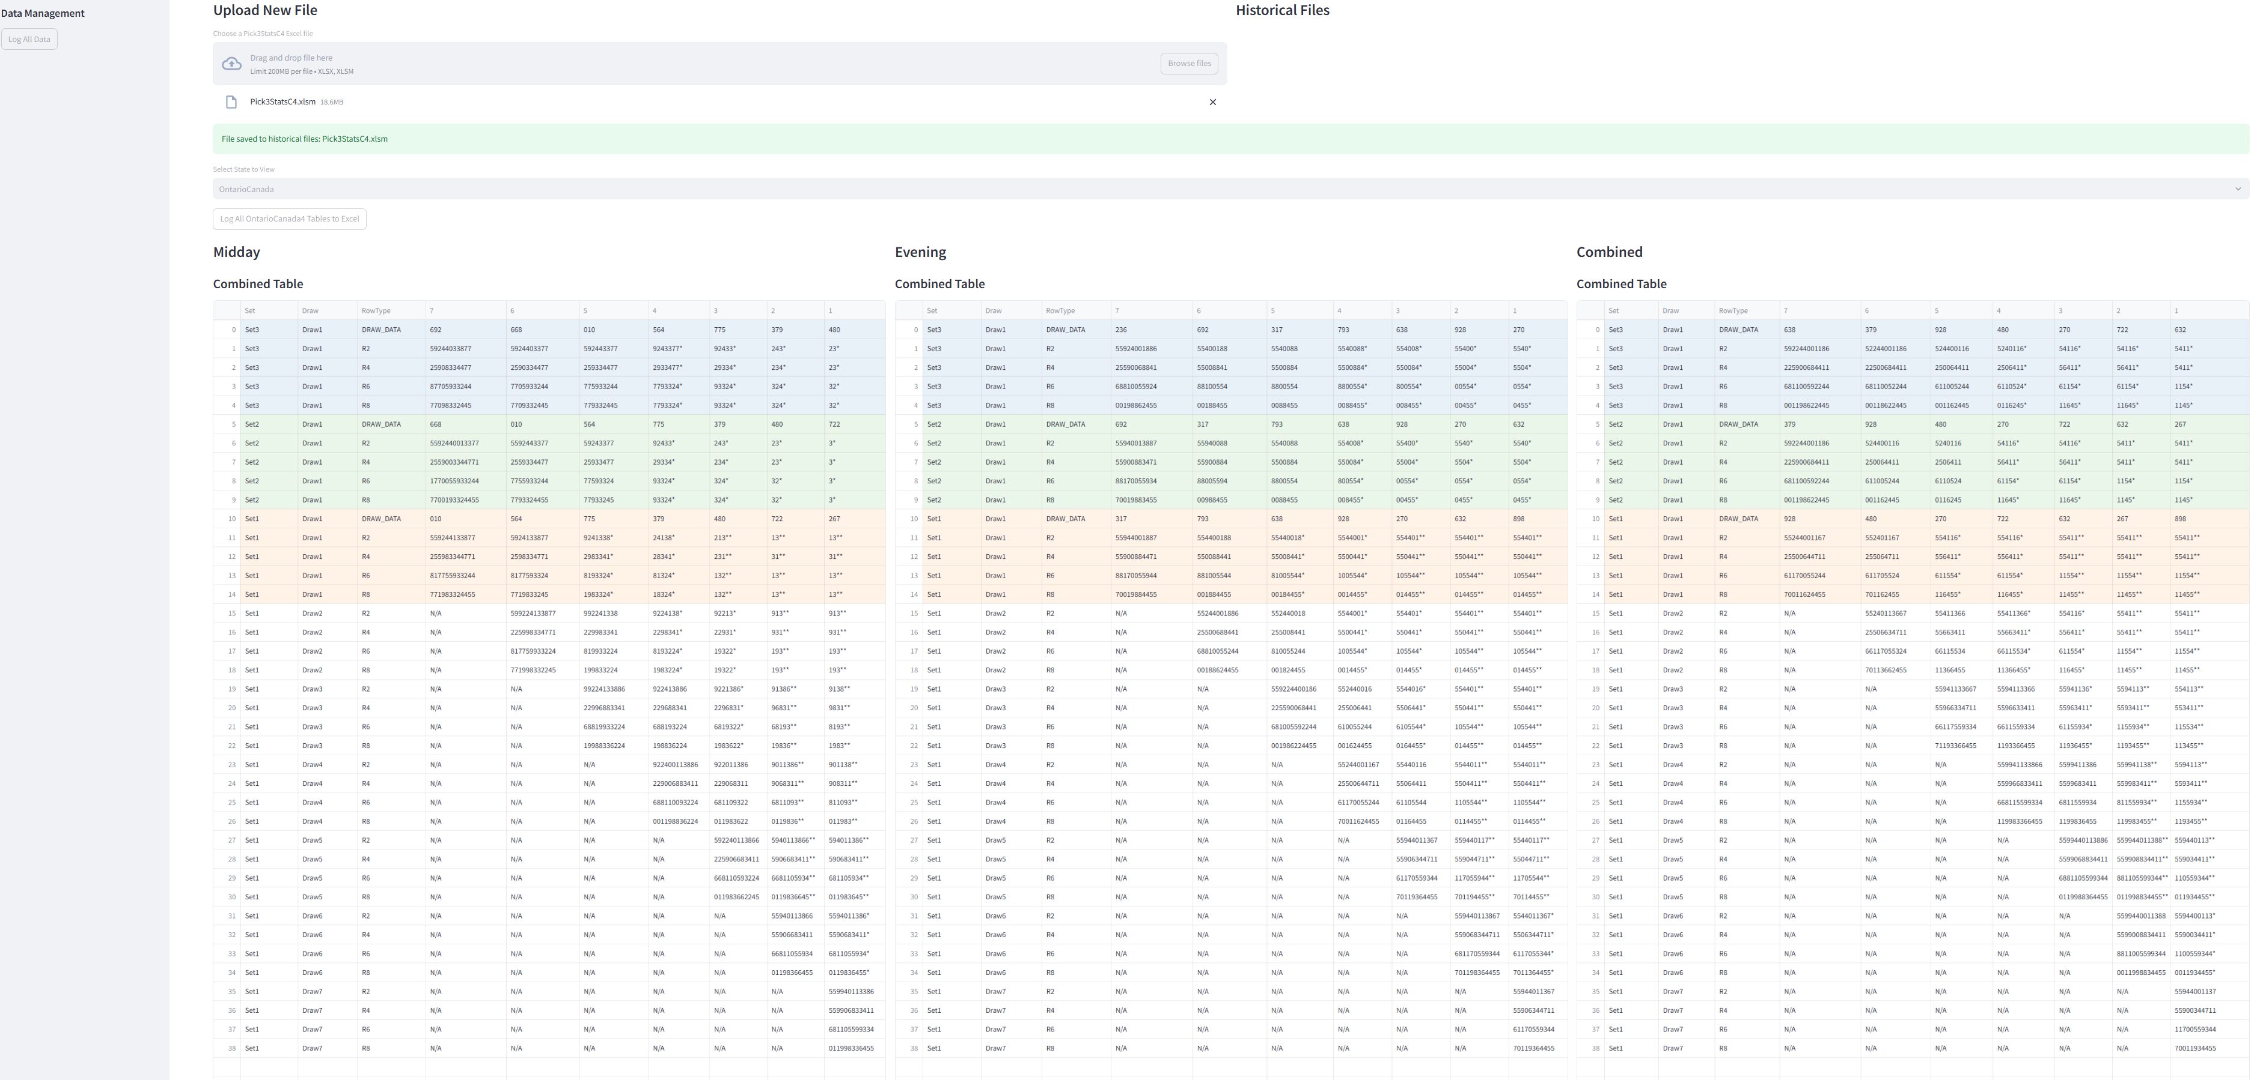

More Functions
